Biography of Session Chairs and Scientific committee members of ICOPH’2018
From North South University, Bangladesh

1.

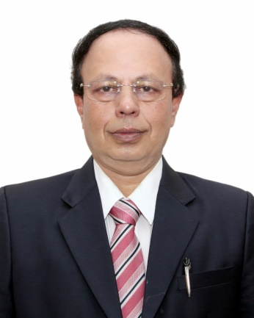

Professor Gias U. Ahsan has been serving as the Pro Vice-Chancellor (D) of North South University (NSU), a top ranked university in Bangladesh and recognized as the center of excellence, higher education & research. He has also been serving as the Dean, School of Health & Life Sciences(SHLS) where Genome Research Institute, NASA funded Climate Research Center & Global Health Institute had been established under the leadership of Prof. Ahsan. These institutions have been awarded with research & innovation program funding from Canadian IDRC, NIH (USA) World Bank & GoB. Prof. Ahsan has over 28 years of professional experience as a senior administrator, teacher & researcher at North South University, Ministry of Health & other recognized institutions. He has pioneered Public Health higher education in the private sector of Bangladesh, which is widely recognized and appreciated.

Prof. Ahsan has graduated with Ph.D. degree, majoring in Epidemiology (2003) and DTM&H (1992) from the Faculty of Tropical Medicine, Mahidol University. He has been awarded Fulbright Scholarship from WHO. Prof. Ahsan obtained his Master degree (MPHM) from ASEAN Institute for Health Development, Mahidol University & his MBBS degree from Chittagong University. He has been awarded merit scholarships across all levels of his education.

A selected few highlights of his career achievements & awards are as below:
- Over 100 peer-reviewed journals & conference papers published
- Over 50 keynote papers presented at national and international conferences
- Outstanding research achievement awards from TDR/WHO & from North American universities
- Received Most Outstanding TROPMED Mahidol University Alumni Award, 2015
- Visiting scholar and chair of notable number of international & national scientific seminars
- Editorial Board Member of two international & national journals

Prof. Ahsan is serving as the current Chairman of University Statutory Committees, comprised of Leave Committee, Need Assessment Committee, Travel & Research Grants Committee, Library Committee etc. Also, he has been serving as the Vice-Chairman & member of other University Statutory Committees like Syndicate, Academic Council etc.

He has taken leadership role for MoU signing with universities like John Hopkins, Harvard, University of Maryland, George Washington University etc., covering top-ranked universities across North America, Europe, Australia & Asia.

